**Downloading of TEMPO using bash**

**STEP 1**: Create an account on <https://urs.earthdata.nasa.gov/users/new>

**STEP 2**: Access the EARTHDATA Search website for TEMPO L3:

[https://search.earthdata.nasa.gov/search?fi=TEMPO&fl=3%2B-%2BGridded%2BObservations&as[instrument][0]=TEMPO](https://search.earthdata.nasa.gov/search?fi=TEMPO&fl=3%2B-%2BGridded%2BObservations&as%5binstrument%5d%5b0%5d=TEMPO)

**STEP 3**: Select between: (a) **NO2**, (b) **HCHO**, (c) **O3** or (d) **Cloud** variables

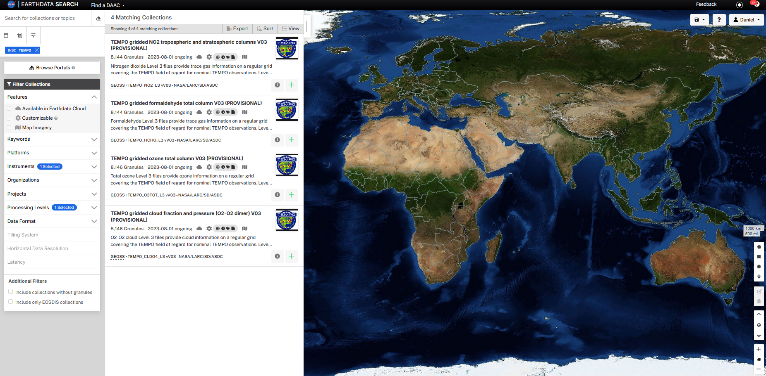



**STEP 4**: Next step is choosing the time interval using (a) **Granule ID(s)** or (b) **Start**/**End** drop menu (recommended). After the selection click in (c) **Download All** button.

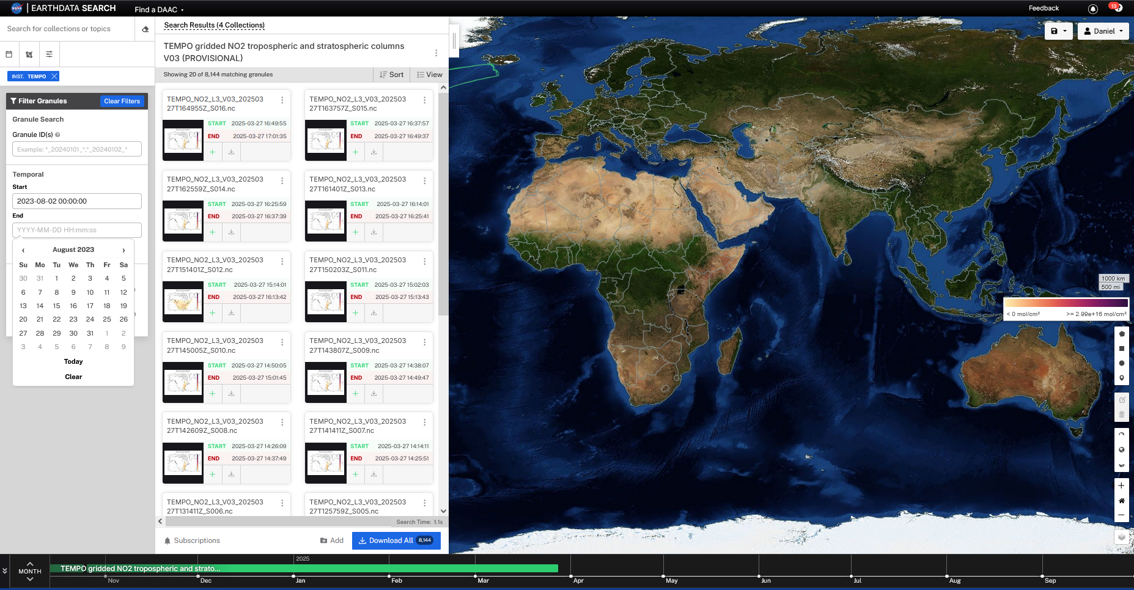



**STEP 5**: Next select (a) **Download all data** option and click (b) **Done** button.

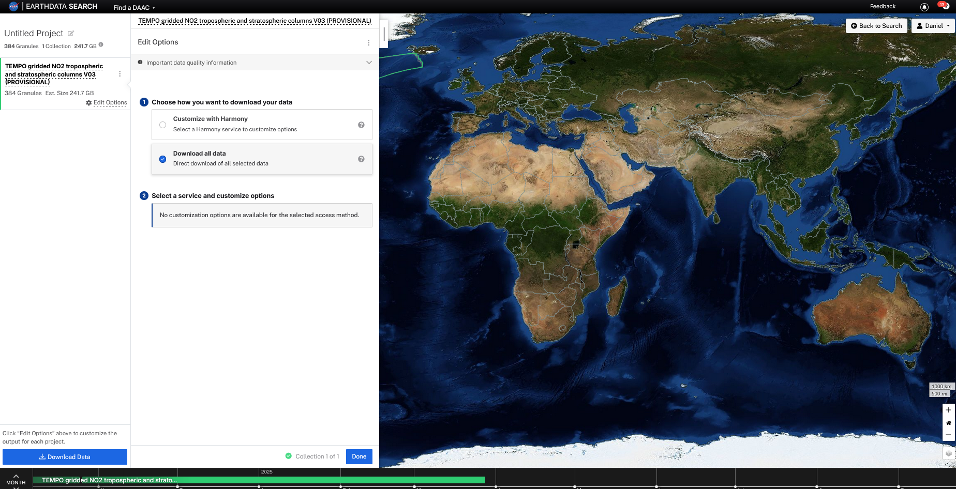



**STEP 7**: Click on (a) **Download Data** button.

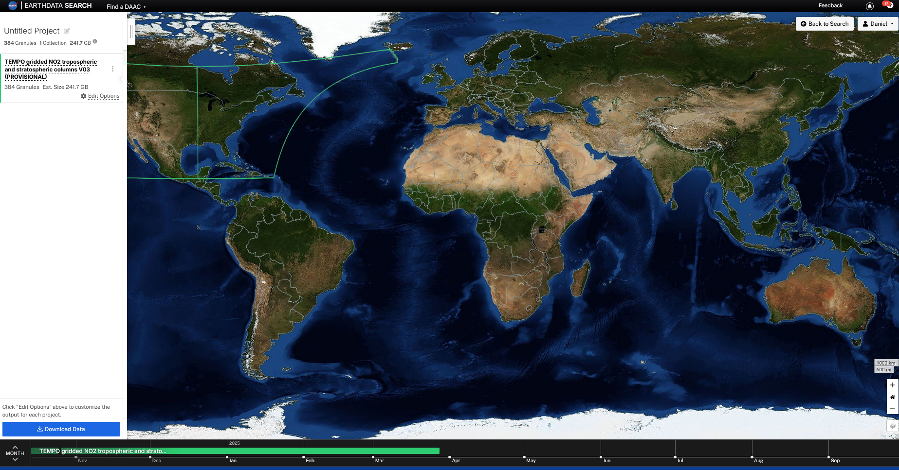



**STEP 7**: Go to (a) **Download Script** tab and (b) **save** the script.

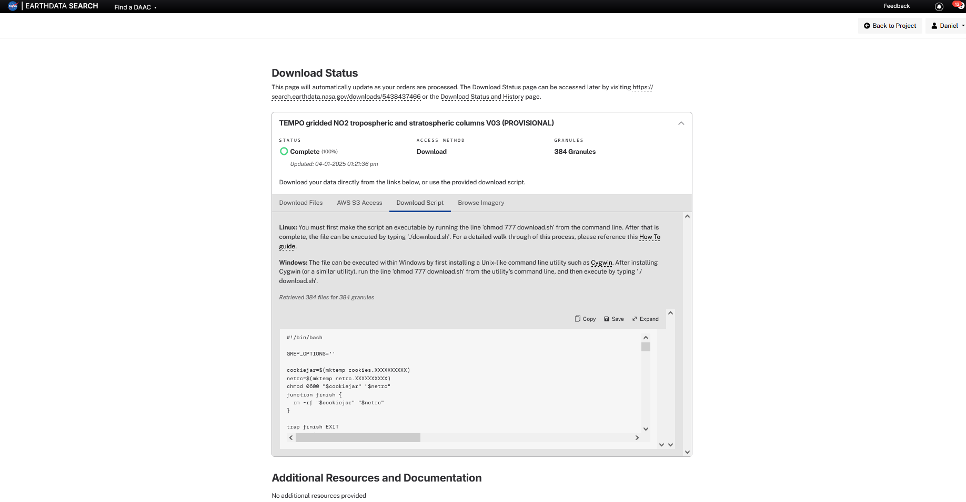



**STEP 8**: Change the permission of the script to run (chmod +x download.sh) and run the download script (./download.sh) using the credentials created in **STEP 1**.